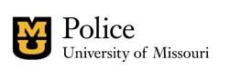
July 10, 2023
MUPD makes arrest in exposure incident
The University of Missouri Police Department has arrested Dennis Allen, 26, of Columbia, on charges in connection with an exposure incident on Sunday, July 9, on south Ninth Street near downtown.
Allen, who is not an MU student, was arrested at about 10:30 a.m., Monday, July 10, on the following charges: One count sexual misconduct 1st degree (Revised Missouri Statute: 566.019) and on an outstanding warrant for sexual misconduct 2nd degree (Revised Missouri Statue: 566.095).

Allen was transported and booked into the Boone County Jail. A bond was set at $1,500.

There is no more to release at this time, and the case remains under investigation.

