Commendation - Complaint Form
University of Missouri Police Department

We appreciate your feedback regarding this department and our employees. Each step of the process we use to investigate a complaint is outlined in the attached brochure or on our website mupolice.missouri.edu. This form may also be completed and submitted online for your convenience.

I would like to submit a:

Commendation ______ Complaint ______

Name: First ______________________ Last ____________________ Email: ___________________________

Cell Phone: ______________________ Work Phone: ________________ Other: _______________________

Address:
Street
City State Zip Code

If you are submitting a complaint, we are committed to thoroughly investigating all complaints that are brought to our attention. To aid us in this endeavor we request you provide the contact information above. Individuals who do not respond to investigators within 7 business days will be presumed to have no further input or information to add to the investigation.

Please provide a brief explanation of the nature of your commendation or complaint below. Please use additional sheets of paper as needed.

Below Fields for MUPD Personnel
DATE RECEIVED: ____________________
RECEIVED BY: ____________________
HOW RECEIVED: ( ) In Person ( ) By Phone ( ) E-mail ( ) Other
DATE SENT TO INTERNAL AFFAIRS:____________

(Forms may be mailed or returned to 901 Virginia Avenue, Columbia, MO 65211)

The commendation-complaint form included with this brochure can be completed and returned to MUPD at:

University of Missouri Police
Support Services Commander
901 Virginia Avenue
Columbia, MO 65211

OR

Emailed to:
RichardsonKS@missouri.edu

CITIZEN’S GUIDE TO MAKING COMMENDATIONS AND
COMPLAINTS

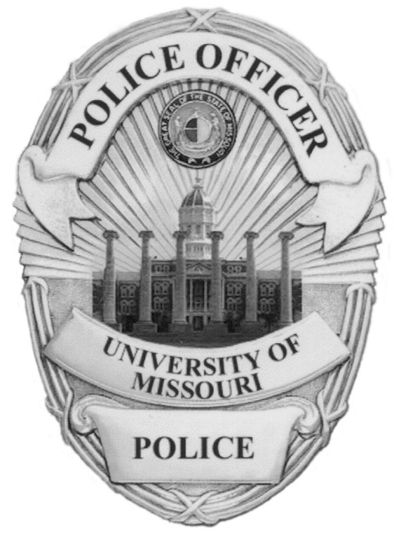

Commendations or complaints can be made twenty-four hours a day / seven days a week:

- Online at https://mupolice.missouri.edu/complaint
- In person at MUPD, which is located at 901 Virginia Avenue, Columbia, MO, 65211
- By calling (573) 882-7201 and asking to speak with the shift supervisor.

Individuals reporting personal interactions, or events they witnessed involving our employees, may choose to remain anonymous.

DEPARTMENT POLICY

It is the policy of the University of Missouri Police Department to ensure integrity is maintained through an internal system where objectivity, fairness and justice are assured by intensive and impartial investigation.

COMPLAINT PROCESS

While complaints may be submitted anonymously, our investigators can complete a more thorough investigation if they can contact the complainant for follow-up questions and to clarify details. Complainants who provide their contact information will be notified by an investigator that their complaint was received within three business days of the complaint submission. When the investigation is complete, the complainant will be contacted with information regarding the findings and conclusion of the investigation. Complainants/witnesses who do not respond to investigators within 7 business days will be presumed to have no further input or information to add in the investigation.
Submitted complaints are assigned for investigation by the Internal Affairs Division. Line supervisors may be assigned to investigate complaints of a less serious nature, such as a misunderstanding between a citizen and an employee, as well as minor breaches of policy (where the outcome will typically produce an action less than suspension, demotion, and/or termination). Allegations of violations of criminal law, reports of corruption, breaches of civil rights, major policy violations (outcomes which would typically produce suspension, demotion, and/or termination), allegations of a sensitive nature, and any investigation determined by the Chief of Police to require investigation by Internal Affairs, will be investigated by the Internal Affairs function or, in their absence, a designee. Complaints involving the Chief of Police will be conducted via an external review.

COMPLAINT FINDINGS

All complaints brought to the attention of the department are investigated to a conclusion of fact. Possible outcomes are:

Sustained – complaint determined to be valid and either the agency or its employee(s) are responsible for some causal act or omission.

Not Sustained – complaint determined to be valid, however it could not be determined whether or not the agency or its employee(s) are responsible for causal act or omission.

Unfounded – complaint determined to not be valid (i.e., the situation described did not occur).

Exonerated – complaint determined to be valid, however the agency or its employee(s) acted appropriately.

An annual summary of Internal Affairs investigations is posted on the department’s web site: https://mupolice.missouri.edu/complaint

COMMENDATIONS

We are always happy to hear of your positive experiences with our personnel! Information we receive involving positive contacts/experiences with our staff are forwarded on to the employee, their supervisor, and placed in their personnel file. If you wish to commend an employee, please follow the instructions on the front of this brochure.

MORE INFORMATION

For more information contact the department’s Internal Affairs Function at (573) 884-0154.

